Sound 3D.
With a three-dimensional graphics would be foolish not to have a three-dimensional audio, is not it? That's the challenge, we now try to solve, for AC3.
What would like to receive from the three-dimensional sound? As a minimum, so you can compare the visible image and its sound design. Simply put, if a bee flies before us, then want to hear it exactly in the place where it flies, and not just a uniform hum from all speakers. However, we have restrictions on computing power; a serious problem size used audio files and stereo sound, as a basis. In this article we consider the dynamic audio control.
First, let's see, what is a three-dimensional audio and how it is formed. Just want to specify that this article deals with point sources of sound, the sound of which can be approximated by mono, such as a bee. We also have listener of the human species with two working ears ☺. Three-dimensionality of sound due to the presence of a man two ears in different parts of the head. In fact, all a bit complicated, but we have enough and such a determination. The source of sound in space, in general, are at different distances from each ear listener. Therefore, the sound from the source is the differential distance and lose different amounts of energy (volume) on the road. Also, the sound passes through the listener's head and, again weakened (it is called a shadow effect).
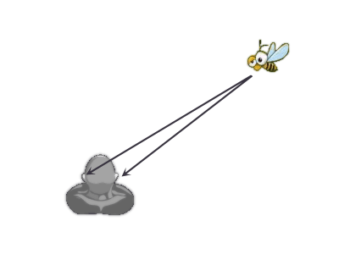
The picture shows that the distance from the bee to the right ear is smaller than to the left. Also the sound in the left ear reaches the listener over the head. Based on these data the human brain determines where the sound source.
From the sound management tools we have the object "SoundTransform" and its properties "pan" and "volume". "Pan" controls the panorama, i.e. manages the allocation of the playback of audio data on the right and left channel. "Volume" controls the overall loudness of playback channels. First, Let us pan.
Using the "pan" you can play part of a sound wave in the right or left channel. For simplicity of experiment, let bee flies around the head listener at ear level on a circle.
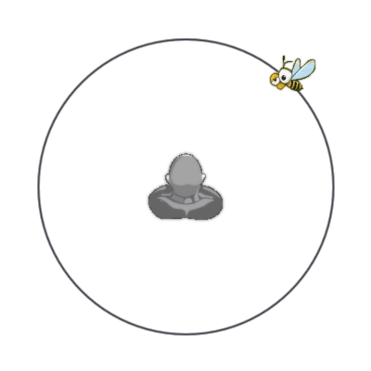
I.e. all sound, which emit the bee, we must expand to 2 channels left and right. Like this:
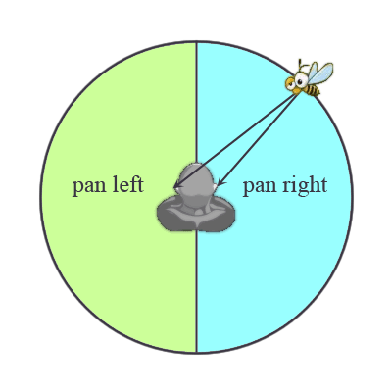
As a result, we have to get a transition from 1 - bee in front of the right ear (full right pan); to 0 – bee in front of the nose (zero pan); -1 - bee in front of the left ear (full left pan); 0 – bee from behind (zero pan); and again 1 (full right pan). Circle has been closed. It turns out the dependency and it looks like the sine or cosine of some angle. We choose the angle between the bee and the right ear (Who can find a reason why? The text have a hint), the result is cosine as a control function.
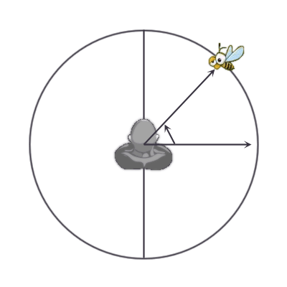
What we have mathematically? Let the bee flies in a circle in a horizontal plane at a height of listener ears, around his head, the coordinates of the listener and the bees are known, then mathematically it looks like this:
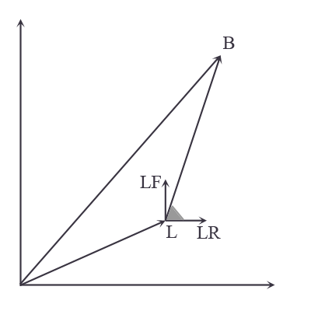
B – Bee scene position
L – Listener scene position
LR – Right listener direction (normalize)
LF – Forward listener direction (normalize)
– Dot product
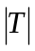 – Modulo of the vector T.

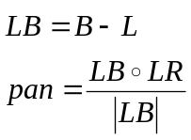

It turned out fairly simple expression for calculating the sound pan in the horizontal plane.
Complicates, bee mutinied and refused to fly in the plane of the head, and wanted to fly the ball around the head. Something likes this:
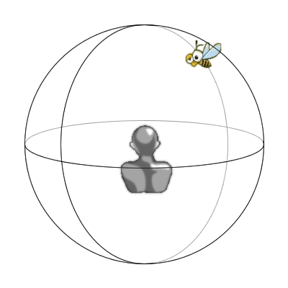
Mathematically, this can be summarized as follows:
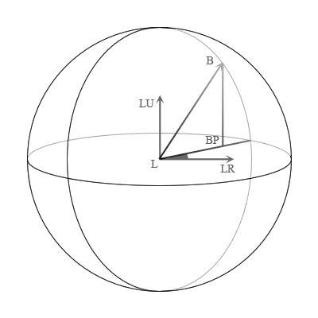
At the picture shows clearly that if we try to use the formula for calculating the plane, we get the angle BLLR, instead of the angle BPLLR. To find the angle panoramas must be mapped vector LB on a horizontal plane of the listener. Then, using the vector-projection to calculate the panorama of the previous formula.
На рисунке очень хорошо видно, что если мы попробуем воспользоваться формулой расчета для плоскости, то получим угол BLLR, вместо угла BPLLR. Для нахождения угла панорамы надо спроецировать вектор LB на горизонтальную плоскость слушателя. А потом, используя вектор-проекцию, рассчитать панораму по предыдущей формуле.
L – Listener scene position.
B – Bee scene position.
LU – Up listener direction (normalize).
LR – Right listener direction (normalize).
BP – Vector-projection to listener plane.
– Dot product.
– Cross product.
– Modulo of the vector T.

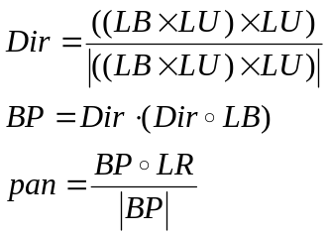

So, we were able to obtain a formula for calculating the panorama of sound for a point sound source located anywhere in three dimensional space. For practical purposes, we can simplify the expression and does not project a vector onto the plane LB listeners. For the average acoustic result is very similar. In addition, when using the projection at small angles between the LU and LB may be very abrupt change in the panorama, which is not very good. In the example demonstrate both ways, and you can compare them yourself (see the function calcPan ()).
Now we'll look to loudness. Sound volume decreases in proportion to the distance from the source to the receiver. To simplify the mathematics, we assume that the volume decreases linearly. The problem is that in nature there is such a thing as the energy of a sound wave, which determines the range of sound propagation. In our case, the maximum available volume is always equal to 1. So we have to enter the maximum distance at which we heard the sound. Thus, the dependence of sound from a distance will look like this:
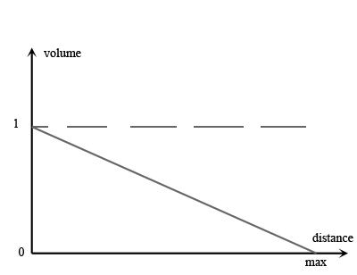
Hence, the volume will be assumed so:
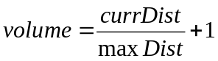

That's all. This mathematics is sufficient to simulate the flight bees in three-dimensional space. The only thing that is worth adding that the right ear always hears about 20% of what it hears the left and vice versa. And this must be taken into account in the calculations ;).
To see this, look (and listen) at the demo or download the example.

